www.lewismoten.com
lewis@moten.com
October 24, 2003

Lewies Validation Code Image - Part 2

Purpose
This software is used to verify that the end-user is in fact, a human being.

Drawbacks
Vision impaired individuals may not be able to pass the test alone. Not section 508 compliant.

Summary
Prevent content and processes from being misused for spam or inappropriate use. An image is displayed to the end-user. An attempt is made to prevent OCR recognition by agents, spiders, or artificial intelligence to gain access to content or processes. The image will display a “code” to the user that they are required to enter into a field provided.

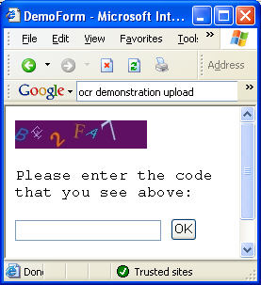

In our last episode
Part one of this tutorial walked you through the initial setup of how to draw random text on an image. It also helped you setup your website to use the image with sessions to verify that the end user is a human. This method of using images is now successful of preventing a lot of agents on the internet from getting past your verification. However, some of you need tougher security. You may need some way to prevents agents that use optical character recognition (OCR) from getting into your website.

As I do not have any OCR software to test with, I will not guarantee the accuracy of blocking OCR software. There are many types of software out there with strengths and weaknesses, so it would also be hard to say that it blocks all of them. Now that that has been stated, I will make the following assumptions that make help you prevent OCR software to be successful when reading each character:

- Rotating (0 degrees, 30 degrees, etc.)
- Adjusting font-size (10pt, 24pt)
- Adjust font style (bold, italic, underline)
- Changing font family
- Offset x/y coordinates so as not to appear on a strait line
- Changing colors

The Matrix Can Rotate
To rotate text, we need to transform the canvas. Actually – the canvas is actually being rotated rather then the text. One of the first things we need to do is to determine where the center of the character is. In Part 1, we were able to determine the width, and height of the character using the Measure String method on the graphics object. We also passed in the current position where the next character was to be drawn. Let’s take a look at how I plan to rotate the canvas:

Private Sub RotateCanvas(ByVal g As Graphics, ByVal degrees As Single, ByVal center As PointF)

' Rotate way we approach the canvas
Dim mx As New Matrix
mx.RotateAt(degrees, center)
g.Transform = mx

End Sub

The matrix is an object with instructions that helps our graphics object transform the canvas self. You can’t touch, feel, or smell it – but it is there. It receives the center point at which to rotate around – and this is the center f the current character we are drawing. Let’s take a look at how I modified the Draw Character routine and added a Rotate Canvas method:

Private Sub DrawCharacter(ByVal g As Graphics, ByVal character As String, ByRef position As PointF, ByVal font As Font)

Randomize()

' determine actual height/width of character when drawn on image.
Dim TextSize As SizeF = g.MeasureString(character, font)

' Determine where the center of the character will appear on the canvas
Dim CenterCharacter As New PointF
CenterCharacter.X = position.X + (TextSize.Width / 2)
CenterCharacter.Y = position.Y + (TextSize.Height / 2)

' Determine number of degrees to rotate
Dim MaxDegrees As Single = 45
Dim Degrees As Single = ((MaxDegrees * 2) * Rnd()) - MaxDegrees

' Rotate way we approach the canvas
RotateCanvas(g, Degrees, CenterCharacter)

' Draw the character
g.DrawString(character, font, New SolidBrush(Color.White), position)

' Rotate the canvas back to its original state
RotateCanvas(g, -Degrees, CenterCharacter)

' move virtual cursor to next characters position
position.X = position.X + TextSize.Width

End Sub

Here you can see that after I get the size of the text, I determine the center position of the character with a little algebra. The center of the character is an offset of the position by half of the characters height and width.

Next, I state the maximum rotation in degrees that I will allow. I choose 45 degrees, but you can adjust this for your own preferences. I randomly choose a value between -45 and 45 degrees with some more algebra.

x = ((MaxDegrees * 2) * Rnd()) – MaxDegrees
x = ((45 * 2) * Rnd()) – 45
x = (90 * Rnd()) – 45
x = -45 to 45

Now comes the powerful part. We create a matrix and tell it to rotate at the center of the character. Anything written now will be rotated. The x/y coordinates will be based around the center.

Nothing has changed with our old “DrawString” line. But afterwards, we need to rotate the canvas back to its original state, or the next graphic will be based on the previous rotation.

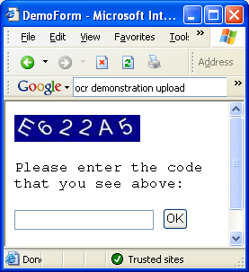

When size matters
To further confuse OCR readers, we can make fonts big and small. We can do this in our code with just two lines. Place the following code in the DrawCharacter method just after you randomize.

' Determine font size
Dim RandomFontSize As Single = (24 * Rnd()) + 12

' Apply changes to font
font = New Font(font.FontFamily, RandomFontSize, font.Style, GraphicsUnit.Pixel)

Here, I assign a random size between 12 and 36. You may want to play around with this. If the characters are too big, they may be displayed out of the visible range of the canvas. I have also noticed that the smaller sizes don’t always render as anti-aliased with smooth edges. They appear to have jagged distortions in curves and lines.

I then setup the font to reflect the new changes. In the following image, you may be able to see how the “A” is a bit jagged.

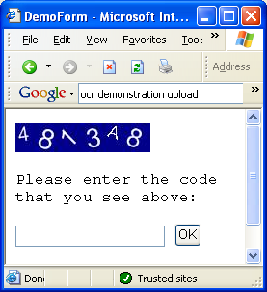

Now, a move obvious problem can be seen. All of our characters are vertically aligned by the top. Later on we will want to offset the x/y position from the center of each character. For now, we need to make a quick fix, and make sure we set the vertical alignment to the middle.

I change the initial Position.Y in the render method:

' determine where the first character should begin
Dim Position As New PointF
Position.X = 0
Position.Y = g.VisibleClipBounds.Height / 2S

This aligns our virtual cursor to the middle of the image. Now we hop back to the DrawCharacter method. After the text size is determined, we modify the Y position to be located at the top of where the character will be written.

' determine actual height/width of character when drawn on image.
Dim TextSize As SizeF = g.MeasureString(character, font)

' set the Y postion where the top of the chacter is written
position.Y = position.Y - (TextSize.Height / 2)

And then at the end of the method, we set the Y position back to the middle of the image itself.

' move virtual cursor to next characters position
position.X = position.X + TextSize.Width
position.Y = position.Y + (TextSize.Height / 2)

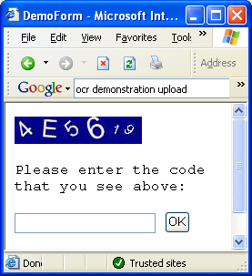

And now, all of our characters seem to be pretty much in line with each other along the center. If you look at the image close, you can notice that the “6” has some space under it. In fact, it seems an invisible line of white space appears below the whole range of numbers. This is because the characters are actually defined with this white space in them. If they did not have it, then they would touch each other and would be very hard to read. I did not research how to determine the exact size of this space. You can accommodate for it by adjusting the initial position Y by offsetting it with a few pixels.

' determine where the first character should begin
Dim Position As New PointF
Position.X = 0
Position.Y = (g.VisibleClipBounds.Height / 2S) + 2S

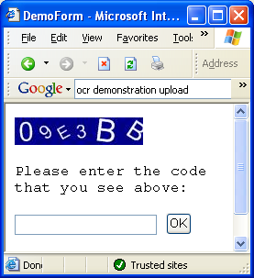

Changing your style
Most of the standard font families give you a range of styles that you may use. These styles are bold, underline, strikeout, and italic. Some fonts will allow you to apply multiple styles to the same family. Here is a simple routine I created to return a random style for the font.

Private Function RandomFontStyle() As System.Drawing.FontStyle

Randomize()

' Initialize our style (regular)
Dim Style As New System.Drawing.FontStyle

' We setup the chance of each style being used.
Const Chance As Single = 25

' apply each style.
If 100 * Rnd() < Chance Then
Style = Style Or FontStyle.Bold
End If
If 100 * Rnd() < Chance Then
Style = Style Or FontStyle.Italic
End If
If 100 * Rnd() < Chance Then
Style = Style Or FontStyle.Strikeout
End If
If 100 * Rnd() < Chance Then
Style = Style Or FontStyle.Underline
End If

Return Style

End Function

You can see that I gave each style a 25% chance of occurring. Because we use binary arithmetic here, I use the Or operator in an uncommon way to add the new style. The values for each style are as such:

Style | Value | Bitmask
Regular | 0 | 0000
Bold | 1 | 0001
Italic | 2 | 0010
Underline | 4 | 0100
Strikeout | 8 | 1000

Binary logic operators work in interesting ways.
Or | Sets all bits to true where either of two bits are true. Others are set to false. Used for adding.
And | Sets all bits to true where both bits are true. Others are set to false. Used for subtracting.
XOr | Sets all bits to true if only one of both bits are true. Others are set to false.
Not | Toggles all bits.

So Now, If I had a Bold style, and wanted to add underline then it would work out to something like this:

Style = Style Or FontStyle.Underline
Style = 1 Or 4
Style = 5
0001 + 0100 = 0101 = 5

Ok, now that our brief introduction to bitwise operations is over, we can move on to our DrawCharacter method. I assigned the random style to the new font.

' Apply changes to font
font = New Font(font.FontFamily, RandomFontSize, RandomFontStyle(), GraphicsUnit.Pixel)

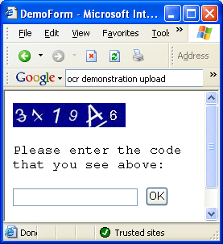

You can always pick your family
Choosing a random font may prove easier then you thought it was. I created a string array of 8 fonts I wanted to use, and then randomly picked one. Take a look at this method:

Private Function RandomFontFamily() As String

Randomize()

' define a list of font families
Dim Families(7) As String

Families(0) = "Arial"
Families(1) = "Courier"
Families(2) = "Courier New"
Families(3) = "Times New Roman"
Families(4) = "Verdana"
Families(5) = "Lucidia Console"
Families(6) = "Comis Sans MS"
Families(7) = "System"

' choose a random font
Dim Index As Integer
Index = CType(Fix(Families.Length * Rnd()), Integer)

' return the name
Return Families(Index)

End Function

Now if the font you want to use is not available, then there is no real need to worry about any errors occurring. It appears that a default font is used. To test this, I returned the string “Lewie” rather then Families(Index) – and the program still ran fine.

Don’t forget to modify your new font line in the DrawCharacter method.

' Apply changes to font
font = New Font(RandomFontFamily(), RandomFontSize, RandomFontStyle(), GraphicsUnit.Pixel)

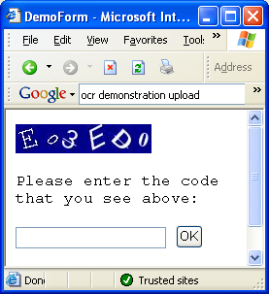

Cleaning up the spaghetti
Our Draw Character method is getting a little dirty with spaghetti. Here is where I like to take a breath and look over everything. First, I took the font assignment out of the draw character code and made its own routine.

Private Function RandomFont() As Font

Randomize()

' Determine font size, family, style
Dim Size As Single = (24 * Rnd()) + 12
Dim Family As String = RandomFontFamily()
Dim Style As System.Drawing.FontStyle = RandomFontStyle()

' create and return new font
Return New Font(Family, Size, Style, GraphicsUnit.Pixel)

End Function

And then I modified the Draw character method:

' Acquire a random font
font = RandomFont()

After looking at the code, I notice that the render method defines a font and continues to pass it to the Draw Character method – but the draw character method keeps reassigning it, so the scope outside of this method is not needed. The highlighted text in Render() is removed.

' setup font to write characters in
Dim Font As New Font("Arial", 24, FontStyle.Regular, GraphicsUnit.Pixel)

' determine where the first character should begin
Dim Position As New PointF
Position.X = 0
Position.Y = (g.VisibleClipBounds.Height / 2S) + 2S

' Loop through each character.
For Index As Integer = 0 To Text.Length - 1

' parse out the character
Dim Character As String = Text.Substring(Index, 1)

' Draw the character
DrawCharacter(g, Character, Position, Font)

Next

Well, now this causes a problem with our draw character signature. We need to remove the parameter “Font”.

Private Sub DrawCharacter(ByVal g As Graphics, ByVal character As String, ByRef position As PointF, ByVal font As Font)

And then the font assignment line is modified as well.

' Acquire a random font
Dim Font As Font = RandomFont()

Ready, Offset, Go!
This is the part where we move each character up, down, left or right of its original position. First, I create my method to return a random offset up to 5 characters from the original position.

Private Function RandomOffset(ByVal position As PointF) As PointF
Dim x As Single = position.X
Dim y As Single = position.Y
Dim max As Single = 5

x = x + ((max * 2) * Rnd()) - max
y = y + ((max * 2) * Rnd()) - max

Return New PointF(x, y)
End Function

Now, my draw character method has many changes. I’m changing most of the position references to a new object that holds the offset information.

Private Sub DrawCharacter(ByVal g As Graphics, ByVal character As String, ByRef position As PointF)

Randomize()

' Acquire a random font
Dim Font As Font = RandomFont()

' determine actual height/width of character when drawn on image.
Dim TextSize As SizeF = g.MeasureString(character, Font)

Dim offset As PointF = RandomOffset(position)

' set the Y postion where the top of the chacter is written
offset.Y = offset.Y - (TextSize.Height / 2)

' Determine where the center of the character will appear on the canvas
Dim CenterCharacter As New PointF
CenterCharacter.X = offset.X + (TextSize.Width / 2)
CenterCharacter.Y = offset.Y + (TextSize.Height / 2)

' Determine number of degrees to rotate
Dim MaxDegrees As Single = 45
Dim Degrees As Single = ((MaxDegrees * 2) * Rnd()) - MaxDegrees

' Rotate way we approach the canvas
RotateCanvas(g, Degrees, CenterCharacter)

' Draw the character
g.DrawString(character, Font, New SolidBrush(Color.White), offset)

' Rotate the canvas back to its original state
RotateCanvas(g, -Degrees, CenterCharacter)

' move virtual cursor to next characters position
position.X = position.X + TextSize.Width

End Sub

You may have noticed that the last line is missing to move the position.Y back to its original state in the middle of the image. I took this out because we modified the offset rather then the position.

position.Y = position.Y + (TextSize.Height / 2)

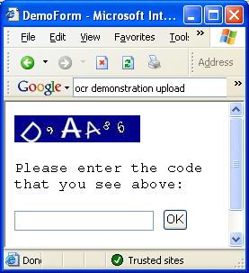

A myriad of color
My next trick is to specify random font colors, with enough contrast against the background. To do this, I will need to go down to the byte value of each RGB value represented in the background. Here is a function I wrote to accept an individual value, and return a contrasting value to it:

Private Function RandomElement(ByVal bgElement As Integer) As Integer

' bytes are hard to work with vb.net so we virtually
' work with them as integers. We need to make sure that
' if they go over 255, then they are wrapped around to
' zero + overflow. If they go under 0, then they are
' wrapped around the other direction 256 + underflow
' bytes are unsigned.

' set byte to its opposite.
If bgElement < 128 Then bgElement += 128 Else bgElement -= 128

' Determine max levels of saturation to offset element
Dim MaxOffset As Integer = 64

' Choose random value to offset element
Dim Offset As Integer
Offset = CType(((MaxOffset * 2) * Rnd()) - MaxOffset, Integer)

' offset the element and prevent overflow
bgElement = (Offset + bgElement) Mod 256

' prevent underflow
If bgElement < 0 Then bgElement = 256 + bgElement

' return the value
Return bgElement

End Function

I was having many problems with bytes and the code was getting very dirty, so I set the code up to use integers. This code returns a color that contrast against the background from 25 to 75 percent.

Next, I created a function to return a random brush with the new color to write in.
Private Function RandomBrush(ByVal bgColor As Color) As Brush

' define Red, Green, Blue elements and get a
' random color that contrasts well against the
' background color.

Dim r As Integer = RandomElement(bgColor.R)
Dim g As Integer = RandomElement(bgColor.G)
Dim b As Integer = RandomElement(bgColor.B)

' create and return a new brush, with the
' contrasting color
Return New SolidBrush(Color.FromArgb(r, g, b))

End Function
You’ll notice how I pulled out each value that makes up the background color and got a contrasting value for it. I then create a new color from these contrasting values. At the same time, I create and return a brush to write the text with.

One last part is to change the Draw Character method.

' Draw the character
g.DrawString(character, Font, RandomBrush(Color.DarkBlue), offset)

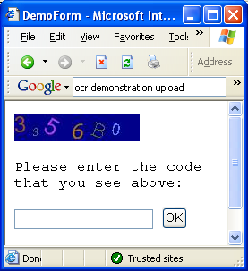

The Color Behind

The next thing I went onto was the background color. Since we need to keep the scope of the background color in two places (Render and DrawCharacter), I placed it within the class scope at the top:

Public Class ValidationCodeImage
Private _Text As String = "" ' verification code to be displayed
Private _Background As Color ' Background color
…

I then created a method to generate a random color on the fly:
Private Function RandomColor() As Color
Dim r As Integer = CType(255 * Rnd(), Integer)
Dim g As Integer = CType(255 * Rnd(), Integer)
Dim b As Integer = CType(255 * Rnd(), Integer)
Return Color.FromArgb(r, g, b)
End Function

Now, the color needed to be assigned. You can do this in the Render method before you paint the background color.

' setup background color
_Background = RandomColor()
g.Clear(_Background)
And finally, there is one last place to change in the Draw Character method.

' Draw the character
g.DrawString(character, Font, RandomBrush(_Background), offset)

With this done, you should begin to see a lot of action going on each time you refresh your image:

Wrapping it up


This wraps up part 2 of my validation code image script. From here, you can make some tweaks to the existing code, such as how much you want to rotate, what are the max pixels you want to offset characters, or adjust how large and small fonts can be. I hope that I made the code simple enough so that you can disable the features that you may not care for either.

For those of you, who are advanced users, please keep in mind that this is a tutorial for educational purposes to introduce developers to the graphics object for the purpose of creating validation images. I understand that discrepancies may occur such as
- characters are not always readable
- characters appear off of the canvas
- colors may not contrast enough
- font is too small
- fonts overlap

I leave it up to you to tweak to your preference. These things can be fixed by
- Limiting number of font families to use
- Changing range of font sizes to render in
- Modifying range of contrast
- Increase image quality to 100% when saving
- Disable or modify the position offsets
- Changing image height/width

Look in the future for part 3 – still more to come.
This script and tutorial are primarily for educational purposes. Feel free to modify the code for binary use in your own applications. Please do not redistribute this tutorial or the source code without written consent.

The law applies to all Federal agencies when they develop, procure, maintain, or use electronic and information technology. Under Section 508 (29 U.S.C. ‘ 794d), agencies must give disabled employees and members of the public access to information that is comparable to the access available to others.

